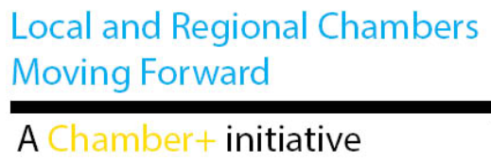
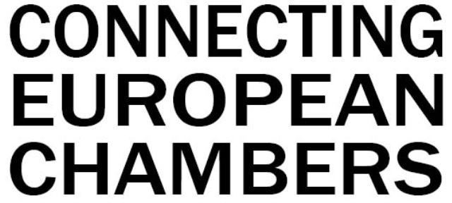
5th edition

03 - 04 July 2019
Committee of the Regions
Rue Belliard 99/101 – Brussels

Background
Many European Chambers benefit from EU funding, to realise their objectives and finance part of their initiatives. Partnerships have been established at regional, cross-border and European level to engage in EU programmes. Also EUROCHAMBRES has developed a wealth of experience at EU level – and beyond – to the benefit of its network.

Against this background, Connecting European Chambers wants to offer local/regional and national Chambers the opportunity to learn about new EU programmes and discover best Chamber practices. The event is part of the broader Chamber+ initiative, which aims to develop the untapped potential for Chambers in better cooperating as a modern network, sharing capacity and develop joint initiatives.

Structure
The seminar will run on Wednesday afternoon (3rd) and Thursday morning (4th), including a networking dinner on the 3rd. Participants will be invited to join three working sessions of their choice, based on their personal interests (to be selected in the registration form):
- Digital Europe
- Skills (apprenticeships/vocational training)
- Entrepreneurship
- Sustainable Economy
- Asia/Africa/Latin America
- Neighbourhood & EU Enlargement
- EU Project Management

During each session, participants will:

- obtain information on upcoming EU programme opportunities for Chambers in 2019/2020
- be invited to briefly present their actions in that area, and expressing their interest for potential common actions
- start collaborating on concrete projects
- get an update of ongoing activities of EUROCHAMBRES in this area (if any)

Participants should therefore come prepared with ideas and best practise. Every participating Chamber should leave the seminar with at least 1 concrete project opportunity to develop.

Registration & Contacts
Registration is free of charge for local, regional and national Chambers from EUROCHAMBRES’ network (including networking diner). Registrations will open on 8 May 2019 at the following link. Only 120 places are available, so tickets will be given out on a first come, first served basis.
More information :
- Roxana Dediu – dediu@eurochambres.eu
- Dirk Vantyghem – vantyghem@eurochambres.eu

Day 1 – Wednesday, 03 July
13.30 | Registration of participants
14.00 | Welcome & Opening session  - Barbara Eibinger-Miedl, Committee of the Regions (tbc)  - Arnaldo Abruzzini, CEO EUROCHAMBRES  - Mariya Gabriel, EU Commissioner for Digital Economy (video intervention)
14.30 | Looking forward: highlights of the new Multiannual Financial Framework (2021-2027) – Opportunities for the Chamber network  - Invest EU – Florentine Hopmeier, Member of Cabinet of Vice President Katainen at the European Commission  - New Foreign Policy Instruments – Andrew Jacobs, Head of Unit DEVCO G3, Regional Sector Policy Analysis
15:00 | Break out in 3 parallel sessions
15.15 | Working Session 1  Digitalisation | Working Session 2  Asia/Africa/Latin America | Working Session 3  EU Project Management
16.45 | Networking break
17.15 | Closing plenary  - Chamber+ Platform  - Conclusions Day 1
19.00 | Networking Dinner
Day 2 – Thursday, 04 July
09.00 | Registration of participants & Break out in 4 parallel sessions
9.30 | Working Session 1  Sustainable Economy | Working Session 2  Entrepreneurship |  | Working Session 3  Skills |  | Working Session 4  EU Project Management
11.00 | Coffee Break  Break out in 3 parallel sessions
11.30 | Working Session 1  Entrepreneurship |  | Working Session 2  Sustainable Economy |  | Working Session 3  Neighbourhood & Enlargement
13.00 | - Presentation EUROCHAMBRES Economic Forum, Rome – October 2019  - Conclusions of the event

